- INTRODUCTION
  - PROJECT DESCRIPTION
Professional and technical skills are in high demand in todays competitive job market. Companies now demand that applicants possess more than just academic credentials. To manage real-world work tasks practical knowledge and industry-related skills are equally crucial. As a result many job seekers are unsure if their current skill set aligns with the demands of the positions they want.
Keyword matching and manual evaluation are the mainstays of the majority of conventional resume screening systems and career guidance techniques. These methods frequently fail to provide clear career direction and are unable to accurately identify individual skill gaps. As a result career planning becomes difficult time-consuming and ineffective for many students and job seekers.
The AI-Based Skill Gap Analyzer and Personalized Learning Recommendation System were created to address these issues. Users can manually enter their skills and experience or upload their resume to the system. The system extracts pertinent technical skills using artificial intelligence and natural language processing techniques then compares them with industry-standard job role requirements that are stored in the system. The system uses this comparison to determine the users current skill set and highlights the skills that are required for the chosen or suggested job role.
The system offers step-by-step learning roadmaps and individualized learning recommendations in addition to displaying the skill gaps. These assist users in developing the necessary skills in a methodical manner and enhance their employability. Additionally the system offers visual analysis to help users track their progress over time and understand their current skill level such as skill gap charts skill match percentages and confidence levels. All things considered this project functions as an intelligent career guidance platform that links job seekers abilities with industry demands and encourages lifelong learning and well-informed career choices.

Problem Statement
Employers are increasingly expecting candidates to have both academic credentials and industry-relevant technical skills in todays competitive job market. Nonetheless a lot of job seekers struggle to determine whether their current skill set aligns with the demands of particular positions. Confusion and uncertainty during job applications and long-term career planning are frequently caused by this knowledge gap.
Manual evaluation and simple keyword matching are the mainstays of both general career counseling systems and traditional resume screening methods. These methods frequently fall short in identifying specific skill gaps and in accurately evaluating a candidates true technical abilities. As a result many job seekers are unable to make well-informed decisions about developing their skills and career planning becomes ineffective.
Furthermore current systems do not provide visual aids or tailored learning recommendations to assist users in filling in their skill gaps in an organized manner. Career advancement is slowed and uncertainty is increased in the absence of automated skill evaluation semantic analysis and personalized learning recommendations. For successful career development an intelligent system utilizing artificial intelligence and natural language processing is needed to evaluate resumes find skill gaps based on industry standards and offer customized learning recommendations.

Objective of the Study
The AI-based Skill Gap Analyzer and Personalized Learning Recommendation System attempts to automate career assessment and support professional skill development by utilizing Artificial Intelligence. This idea takes on common flaws in job application reviews and guidance services, using information-based methods to offer fresh perspectives.
Key parts include these elements:
- A fresh look at someone's work history helps spot gaps in their skills. Using smart software, it digs deeper than just comparing job titles. This tool understands context, so it sees what really matters in a career path. Instead of counting keywords, it reads between the lines. Accuracy improves when machines grasp meaning like humans do.
- From start to finish, handling resumes is taken care of securely through upload systems that protect data. Text pulls out quickly once a file arrives, no delays. Processing follows right after, turning raw info into structured records. The entire resume process is handled by the service. This includes fast text extraction and processing safe resume uploads and semantic skill analysis. By automating these processes manual labor is decreased and review accuracy is increased.
- Data analysts web developers and AI engineers and many of the industry-standard job roles that the platform supports. It evaluates the users readiness by comparing their current skills to the requirements of specific job roles.
- For every user the system generates a different study schedule. It suggests structured learning paths practical projects and pertinent online resources based on identified skill gaps.
- Graphical analytics in the form of skill gap charts confidence indicators and talent match ratings are included in the program. Users can quickly assess their progress difficulties and strengths with the help of these charts.These visuals help see strong points, hurdles, even growth - fast. Not just numbers, but clear snapshots guiding next steps without confusion.
- Security begins with clear user ID checks. A control panel handles job roles, skill sets, plus setup details. Better upkeep follows. Growth becomes easier. Risks drop when settings stay under watch.
Scope of the project
The AI-Based Skill Gap Analyzer and Personalized Learning Recommendation System are designed to automate professional skill evaluation and provide intelligent career guidance using Artificial Intelligence and Natural Language Processing. This project aims to provide an accurate, efficient, and tailored solution for career development by addressing the shortcomings of standard résumé screening and generic career counseling systems.
Listed are several key aspects under the project scope:
- The gaps between a user's current skill set and those required by industry are identified with the help of AI-based semantic analysis. This means that the evaluation is accurate and it goes deeper than the simple keyword matching ways of doing it.
- The entire resume management process in the project, which includes secure uploading of resumes, data extraction, pre-processing, and evaluation of both technical and professional skills.
- The platform is equipped with a mix of various industry-standard job roles such as Data Analyst, Web Developer, AI Engineer, etc. It measures the user's skills over the actual working requirements to decide the role readiness.
- After analyzing the discovered skill gaps, the solution provides personalized learning roadmaps, project ideas, and specially selected online learning resources to assist in the targeted skill development process.
- The project is fitted with visual representations such as skill match scores and skill gap charts as a way of helping the user have a quick understanding of their capabilities to assist them recognize their limitations, capabilities along with areas to improve upon.
- The associated functionalities would provide for secure user verification as well as an admin feature that would oversee the user roles, skill datasets, and system settings thereby supporting scalability and maintenance.

2. LITERATURE SURVEY

  - EXISTING AND PROPOSED SYSTEM

2.1.1 EXISTING SYSTEM

The process of searching toward a job and consulting about a were converted into a form that is mainly dependent on job seekers' visiting websites that list the open positions and through which they upload their resumes either through online forms or emails. Even if these methods facilitate digital transfer of resumes, the assessing process is still mainly by hand or very basic keyword-matching techniques. Consequently, the applications occur to a large extent without a proper evaluation of the candidate's skills.
The only form of support offered to the job seekers by these services is the distribution of their resumes. The reasons of application rejection or the comparison of qualifications with job requirements are rarely given to the candidates. The help in shaping a career through writing essays or posting in a blog is offered by some systems, but this material is inflexible and does not accommodate special skills, knowledge or career plans. The communication between recruiters and job seekers is done mainly through e-mails and other means, which creates a situation where the applicants are not able to keep track of their application status.
Because of the lack of of good evaluation and honesty, job aspirants occasionally doubt the preparedness of their careers. They do not have an idea of their specific skill weaknesses and do not ask for guidance on how to enhance their job prospects. This turns the whole process of finding a job into a waste of time, a long one, and a frustrating one.
The existing system faces some drawbacks, comprising:
- Resumes are either subjected to manual review or processed through inflexible keyword-based software.
- Job applications lack comprehensive and individualized feedback.
- The influence of skills and experience on context tends to be overlooked here.
- The process of tracking applications is opaque and unclear.
- Career counselling is extensive rather than individualized.
- There is no training plan or guidance on skill development.

    - PROPOSED SYSTEM
The planned AI-Based Skill Gap Analyzer and Personalized Learning Recommendation System attempts to overcome the limits of current approaches by providing a clever, automated, and job-seeker-centric platform. The technique is intended to help job seekers in identifying their professional strengths and weaknesses, while also offering simple guidance for career progress.
Users can put their resumes or specify their skills and esposure within the proposed system. The system uses artificial intelligence and natural language processing to intelligently locate potential talents and assess them in context, rather than relying on basic keyword matching. The acquired abilities are then compared to certain industry-standard job role standards to assess job readiness.
Rather than just underlining skill gaps, the system actively assists job seekers by developing individualized learning roadmaps. These roadmaps provide step-by-step directions, project ideas, and chosen online learning resources to assist individuals in developing their skills in a methodical manner. Skill match scores and skill gap graphs are examples of visual analytics that promote comprehension and allow users to monitor their development over time.
The proposed system transforms the job search process into a guided and open career development process by automating talent assessment and providing customized suggestions. This method reduces ambiguity, builds trust, and promotes continuous professional growth.
❖ Advantages of the proposed system:
- Provides explicit information regarding skill strengths and constraints.
- Use AI-based semantic analysis to accurately assess skills.
- Recognizes specific skill gaps for certain job roles.
- Creates personalized learning plans and project ideas.
- Improves openness and trust in career planning.
- It saves time by automating resume review and evaluation.
- Encourages lifelong learning and career development.
Module Description
The AI-based Skill Gap Analyzer and Personalized Learning Recommendation System are built using a modular architecture to provide flexibility, scalability, and easy maintenance. The system is split into two primary modules: the Admin Module and the Job Seeker Module. Each module is responsible for certain functions that, taken together, promote smart career assessment and counseling.
Admin Module
The Admin Module serves as the platform's primary control unit. The administrator is in charge of the entire system, including data correctness and safe functioning. This module provides efficient monitoring of users, system settings, and analytical insights generated by AI modules.
The Admin Module's primary sub-features are:
User Management: The administrator can see all enrolled job seeker profiles and control user entry to the platform. This provides regulated use and appropriate system governance.
Role and Skill Configuration: This functionality enables the administrator to create, modify, and remove job roles and the technical abilities required for each. It guarantees that the system stays consistent with present industry requirements and changing labor market needs.
AI Insight Analytics: The administrator has access to trend analysis graphs and analytical reports that show frequently lacking talents among the user base. These insights assist in detecting developing technological gaps and enhancing system recommendations.
System audit logs: The system keeps complete audit records of all important administrative and user activities. This feature improves security, accountability, and transparency by allowing the administrator to monitor system activity.

Job Seeker Module
The Job Seeker Module is the system's primary user-facing element, offering extensive career assistance via sophisticated algorithms. It allows people to evaluate their talents, uncover gaps, and obtain realistic solutions for career advancement.
The Job Seeker Module has the following key features:
Hybrid AI Resume Parser: The system takes a hybrid strategy, combining spaCy PhraseMatcher with Sentence-BERT (SBERT) semantic analysis to extract technical abilities from resumes with great precision. This method assures consistent skill recognition even when talents are described in several situations.
Skill gap visualization: Interactive radar charts compare a job seeker's current skill set to the required skills of a preferred target career. This allows consumers to rapidly grasp their strengths and flaws.
AI recommendation pipeline: A machine learning algorithm based on random forests recommends the top three job roles that are highly suited to the user's current skills. The suggestions are sorted by confidence score to aid informed career choices.
Personalized Study Paths: Based on established skill gaps, the system creates week-by-week training roadmaps. These include project ideas and curated YouTube learning resources to help people gain necessary abilities in a methodical manner.

  - FEASIBILITY STUDY

The feasibility study assesses the feasibility of deploying the AI-Based Skill Gap Analyzer and Personalized Learning Recommendation System in terms of technology, cost, and operation. This study assists to assess if the planned system can be successfully developed, deployed, and utilized in a real-world setting.
1. Technical Feasibility
It establishes if technological and equipment and facilities necessary to carry out the planned system exist and are powerful enough to sustain the system.
AI Models & Frameworks: AI Models and Frameworks: The main characteristic of the system is based on AI and NLP models like spaCy, SBERT and the utilization of ML models. Such tools are currently accessible, open-source, and have good support, thereby rendering it possible to deploy them. The application of pre-trained models reduces both the effort and risk in development highly.
Data Availability and Processing: Mainly, the system depends on user resumes and professional information that are manually typed in as the input data. This data is readily available and can be processed easily by using text extraction and NLP techniques. The resumes in PDF or text formats can be effortlessly parsed and turned into organized information for additional evaluation.
Application Infrastructure: The proposed architecture relies on thelatest web technologies application, i.e. React on the client-side and Flask on the server-side, combined with a relational database. It is a lightweight but powerful tech stack that is suitable in high-end web applications.Besides, the modular design contributes even more to the ease of maintenance and the possibility of scaling.
Performance Considerations: Effieiency of the system will be judged on correctness of resume parsing, how trustworthy the skill extraction is, how fast the recommendations are given, and how long it takes to load the dashboard. The time taken to process the majority of the AI tasks is optimized and done with the use of good libraries, thus the system is able to deliver results within the acceptable response times.
Scalability: The system architecture supports many users at the same time. With appropriate optimization and implementation of the application in the cloud or scalable server environments, the application can contain the growing numbers of users without huge performance losses.
2. Economic Feasibility
Economic feasibility is the viability of the system at an affordable price.
Cost of Development: The project utilizes mainly open-source tech stacks such as Python, spaCy, Flask, React, and SQLite which help in lowering the cost for licensing. The major costs are the time spent on developing the product and the basic computer resources.
Operational Cost: The operational costs are minimum because the technology can run on normal servers or the cloud. Maintenance expense includes updates that are regularly conducted, monitoring, and minor improvements.
Return on Investment (ROI): The system not only spares the expensive career counseling to the job seekers but also minimizes the time taken to tackle and develop skills and be job-ready. The manual assessments of institutions and organizations can be significantly reduced by the platform. The technology, if marketed in the future, could be a source of income through premium features or memberships as its cash-producing capability is already established.
Cost advantage: The comparatively low development and maintenance cost is inconsequential in view of the benefits of the system which are precise skill analysis, individualized learning counseling, and career mapping.
As a result, the venture is financially feasible.

3. Operational Feasibility.
Operational feasibility assesses whether the system may be utilized successfully by its target users.
Acceptance by job seekers: Job searchers are likely to embrace the platform because to its simple design and obvious value proposition. The platform is extremely user-friendly and helpful because it allows users to upload a résumé and immediately obtain skill gap analysis and learning suggestions.
Easy to Use: The system features a simple user interface that doesn’t need specialist technical knowledge. Clear dashboards, graphical charts, and guided recommendations provide seamless communication.
Training and Support: Job seekers require very little training. Basic instructions, tooltips, and help sections are adequate for directing users. Any challenges can be addressed by easy documentation or support channels.
System Reliability: The modular and well-tested design provides stable operation with little downtime, making it ideal for long-term use.

  - TOOLS AND TECHNOLOGIES USED

Frontend Technologies
- HTML5, CSS3, and JavaScript
HTML5, CSS3, and JavaScript are the main technologies used to construct current web apps. HTML5 creates the structural foundation for web pages, CSS3 handles styling and responsive layout design, and JavaScript adds dynamic functionality and interactivity. These technologies work together to provide compatibility across browsers and devices while keeping a user-friendly interface.
The AI-based Skill Gap Analyzer system uses HTML5 to build user registration, login, resume submission, and dashboards. CSS3 provides a clean, responsive, and visually appealing design, while JavaScript handles client-side verification, API connectivity, and dynamic content updates.
- React. js
React. js is a component-based JavaScript framework that is commonly used to create interactive and high-performance user interfaces. It boosts application efficiency by using virtual DOM rendering and enables code reuse, resulting in a more structured and scalable development process.
In this project, React. js is used to construct dashboards for Job Seekers and Admin users. It handles dynamic components such as skill gap graphs, recommendation panels, learning roadmaps, and résumé evaluated results, allows for easy navigation and real-time updates without requiring page reloads.
- Chart. js
Chart. js is a simple JavaScript library for generating interactive charts and graphs. It converts raw data into visually intelligible forms, including radar charts, bar graphs, and line charts.
The Skill Gap Analyzer system employs Chart. js to create skill gap graphics, skill match scores, and comparisons between user talents and job role needs. These graphical components assist users in comprehending analysis findings and tracking progress.

Backend Technologies
- Python
Python is a frequently used high-level interpreted programming language in Artificial Intelligence, Machine learning, and data analysis. It is highly widely recognized for its ease, clarity, and vast collection of libraries.
Python serves as the main backend language for this system. It is utilized for resume processing, NLP-based talent extraction, semantic matching with SBERT, machine learning-based job role prediction, ATS scoring, and database connections. Python is the foundation of the complete application.
- Flask
Flask is a minimal Python web platform which enables the development of RESTful web services. It offers flexibility and seamless integration with Python-based AI packages.
This project uses Flask to create backend APIs for resume uploads, talent analysis, job recommendations, learning roadmap creation, and authentication. It facilitates efficient interaction between frontend and backend elements.
- JWT (JSON Web Tokens)
JWT is a secure way to transfer authentication data between the client and server. It offers stateless authentication and boosts system scalability.
In the Skill Gap Analyzer system, JWT provides secure user authentication and session management. It limits access to secure system functions and sensitive data to authorized users only.
Artificial intelligence and machine learning technologies.
- SpaCy
spaCy is a strong NLP library which allows for rapid and efficient text analysis. It offers tools for tokenization, linguistic processing, and phrase matching.
In this study, spaCy used to parse resumes and the PhraseMatcher is used to extract technical abilities. It transforms unstructured resume content into structured skill data for subsequent analysis.
- Sentence-BERT (SBERT)
Sentence-BERT is a transformer-based deep learning model that analyses semantic similarity and contextual meaning in text.
The Skill Gap Analyzer uses SBERT to semantically compare user talents with job role needs. It recognizes associated abilities even when the exact keywords are not present, enhancing the correctness of skill gap identification.
- Scikit-learn
Scikit-learn is a well-known Python library for generating machine learning algorithms.
In this approach, scikit-learn used to construct a random forest classifier that recommends acceptable job roles based on the user's acquired skill set and ranks the recommendations.
- FuzzyWuzzy
FuzzyWuzzy is a Python library for approximate string matching.
In this system, it is used for handling spelling variants and discrepancies in skill names that are entered manually by users or obtained from resumes, ensuring correct skill mapping.
Database and Storage Technologies
- SQLite/MySQL
SQLite and MySQL are structured data handling platforms that store structured data.
The Skill Gap Analyzer system stores user profiles, harvested talents, job role needs, ATS scores, and recommendation results in these databases, allowing for quick data retrieval and management.
- File Storage System
A safe file storage system is used to keep submitted resumes temporarily for processing. Proper access control assures user data privacy and secure document handling.

Tools for Development and Support
- Git & GitHub
Git is a version control system that monitors code updates, and GitHub offers a platform for collaborative development.
GitHub is utilized for source code management, version control, and project consistency in this project.
- Visual Studio Code (VS Code)
Visual Studio Code is an open-source code editor that offers extensive language and debugging support.
VS Code is utilized as the major creation setup for coding, validation, and debugging both frontend and backend code, resulting in increased productivity and development efficiency.
- Postman
Postman is an API testing tool that verifies backend services.
In this approach, Postman is used to test Flask APIs that support resume upload, skill extraction, recommendations, and authentication.

  - SOFTWARE AND HARDWARE REQUIREMENTS

Hardware specifications

Component | Specification
Processor | Intel Dual Core processor or higher
Processor Speed | 2.0 GHz or faster
RAM | Minimum 4 GB
Hard Disk | 10 GB available space (for application files, browser cache, and downloads)
Network | Broadband Internet connection

Software Specifications

Category | Specification
Operating System | Windows, macOS, or Linux
Web Browser | Google Chrome, Mozilla Firefox, Microsoft Edge, or Safari
Front End | React.js, HTML5, CSS3, JavaScript
Back End Logic | Python with Flask framework
Database | SQLite / MySQL
AI & NLP Libraries | spaCy, Sentence-BERT (SBERT), scikit-learn, FuzzyWuzzy
Authentication | JSON Web Tokens (JWT)
Runtime Environment | Python 3.8 or higher
Development Tools | Visual Studio Code, Git, GitHub

- SOFTWARE REQUIREMENTS SPECIFICATION

The Software Requirements Specification (SRS) spells out exactly what the system has to do and how it should perform. It lays out all the rules, expectations, and limits—no guesswork. Developers and stakeholders rely on this document to stay on the same page and make sure they build the right thing and check that it works as intended.

  - USERS

The primary users of this initiative are the administrator and the job searcher.

Admin:

The admin holds total authority over the complete operation of the platform. It is the administrator who guarantees the integrity of the system, handles the users, assigns the job roles and skill datasets, and keeps a watch on the performance of AI-powered features.

Job Seeker:

The Job Seeker is defined as an individual seeking career guidance as well as skill improvement help. The job applicant has the opportunity to hand in resumes, locate skills lacking, receive AI suggested job roles according to one's capability and go with personalized learning paths all in a safe environment.

User Interfaces

Registration Page:

This webpage is to register new Users looking for jobs in the provided section of the system by providing basic credentials and a profile.

Login Page:

The provision for email and password provision for user and job seekers safety is secured through the interface to everywhere via this interface.

Admin Login Interface:

Once the administrator logs in, he or she is directed to the admin panel, where information related to the entire platform may be viewed and managed: the total count of individuals registered, trends in skill gaps, job roles settings, and the usage statistics of AI features.

Job Seeker Login Interface:
This interface shows the Job Seeker dashboard that gives users the ability to modify their profiles, submit and process resumes, see the results of skill gap analysis, receive suggestions for job roles, get personalized learning roadmaps, and track their career development.
  - FUNCTIONAL REQUIREMENTS

Functional requirements relate to the various tasks and services provided by a specific system so as to comply with user expectations.

The functional requirement states as follows:
- The system should allow to register and securely authenticate their access by using legitimate credentials.
- The system has permit job seekers to upload their resumes in compatible formats for review.
- The system will utilize AI and NLP methodologies to parse submitted resumes and extract relevant technical and professional abilities.
- The system will assess resume quality and provide analytical ratings based on predetermined ATS standards.
- The system will suggest appropriate job positions based on the user's extracted abilities and profile.
- The system will conduct skill gap analysis by comparing user skills with industry-standard job role standards.
- Interactive charts and graphs will show skill gaps and match scores.
- The system will create customized learning roadmaps that include project recommendations and curated YouTube learning resources.
- The system will include an admin module to manage users and viewing analytical insights into skill trends and system usage.

  - NON FUNCTIONAL REQUIREMENTS
Non-functional requirements are the quality aspects of the system, indicating how effectively the system performs its tasks.
Performance
This system does a great job providing the performance that is speedy and effective to the user's way of accessing the service being smooth. Under normal conditions, the processing time is 5 seconds for the uploading of resumes and AI-powered skill analysis. The user dashboard, reports, and analytics pages take 2 seconds to load, whereas backend API requests wait for only 1 second before responding.
Scalability
The system has been built to grow its capacity along with the increase in number of users and data volume. More than 1,000 registered users are supported by the system, over 100 concurrent sessions are handled and more than 50,000 resume records are stored without any performance degradation.
Security
The system uses strict security measures to keep the delicate data of users safe. The passwords of users are hashed and stored securely while access to this system is depending on the responsibilies of the different users which restricts the job seekers, recruiters, and admins to operate only within their authorized areas.
Usability
You get a straightforward, easy-to-use interface—nothing cluttered or confusing. It works smoothly whether you’re on a laptop, tablet, or your phone. Navigation’s a breeze, and the guided steps actually assist you get things done, like uploading your resume, checking the analysis, or looking over recommendations.
Reliability
The system takes over to keep consistency in operations and to maintain data integrity all the time. The uploading of resumes, AI processing, and generation of recommendations are all done reliably with no data being lost or corrupted.
Maintainability
The system uses a modular, layered setup built on Flask. You can swap parts like AI models, recommendation engines, or database modules whenever you need—no need to worry about breaking the whole thing or messing up the user interface. This kind of design makes it easier to debug, test, and roll out new features down the line.
Portability
The system uses a modular, layered setup built on Flask. You can swap the parts like AI models, recommendation engines, or database modules whenever you need—no need to worry about breaking the whole thing or messing up the user interface. This kind of design makes it easier to debug, test, and roll out new features down the line.
- SYSTEM ARCHITECTURE / DESIGN
  - SYSTEM PERSPECTIVE
- System Perspective Design

System design is the procedure of defining the architecture, components, modules, interfaces, and data essential for a system to accomplish its goals. Consider it as the vital link between determining what is needed and actually developing the software.
Job Seeker
Admin Dashboard
(User Management,
Role Management)
AI Analysis Engine
(Resume Parsing, Skill Gap Analysis)

Recommendation module(Job Roles, Learning Roadmaps,Projects)
Admin
Database
(Users, Resumes,
Analyses, Roles)

Figure 4.1: System perspective design of AI-Based Skill Gap Analyzer and Personalized Learning Recommendation System
The system perspective depicts the high-level contact between users and system components, with Job Seekers and Administrators accessing the platform through a web interface to conduct career evaluations and management duties. AI modules manage resume processing, skill gap analysis, and customized recommendations, with all system data and outcomes stored centrally in the database to ensure seamless functioning and clear data flow.
  - DATAFLOW DIAGRAM / CONTEXT DIAGRAM

- Level 0 DFD

Job Seeker
Admin
AI-Based Skill Gap Analyzer and Personalized Learning Recommendation System
Uploads resume, Manual Skill input,
Select target role
Skill gap analysis,
Job recommendations,
Learning roadmap,
ATS score
Analytics reports, Skill charts,
Audit logs
Manage users,
Manage job roles,
Monitor system

Fig4.2: Context Diagram of AI-Based Skill Gap Analyzer and Personalized Learning Recommendation System

The diagram depicts the overall interaction between the Job Seeker, Administrator, and the System. The Job Seeker submits inputs such as resume uploads, manual skill information, and desired job positions, the system processes using AI techniques to generate results including skill gap analysis, job recommendations, learning roadmaps, and ATS scores.
The administrator interacts with the system to manage users and job responsibilities, monitor performance of the system, and view analytics reports. The system handles all operations centrally, assuring seamless data transmission, precise analysis, and efficient platform management.

- Level 1 DFD of Admin
View Analytics
Login
Success
Login
Verified
Login Details
Analytics Database
User Info
Retrieved
Request Analytics
Users/Roles Details
Admin
Manage Users/Roles
Update User/Roles Data

Figure 4.3: Level 1 DFD of Admin

The diagram above depicts the key features of the Admin module as well as the data flow within it. To begin, the administrator logs into the system, and the credentials are compared against stored login information. Once authenticated, the administrator may administer users and roles, as well as access analytics and platform metrics, with all essential data being stored in and retrieved from the relevant databases.

Level 2 DFD of Job Seeker
View Analytics Results
Suitable Job Roles
Job Role Recommendation
Analysis Reports Database
Skill Gap Analysis
Skills and Job
Role Database
Resume
Repository
Registration and Login
Job Seeker
User Database
Resume Upload and Parsing
Validate Data
Upload Resume
Parsed Resume
Extracted Skills
Analysis Reports
Job Matches,
Learning Roadmaps
Request Analysis Reports
View Results

Figure 4.4: Level 1 DFD of Job Seeker

The preceding diagram depicts the detailed workflow of the Job Seeker component in the AI-Based Skill Gap Analyzer and Personalized Learning Recommendation System, as well as how data travels between processes and databases. Initially, the Job Seeker provides registration or login information, which is validated against the User Database. Following successful authentication, the user submits their resume, which is parsed and stored in the Resume Repository, while the extracted talents are sent for further analysis. The Skill Gap Analysis process compares the acquired skills with the necessary work role competencies stored in the Skills and Job Role Database to discover any missing skills. Based on this study, the Job Role Recommendation process generates relevant job responsibilities and training recommendations, which are then stored in the Analysis Reports Database. Finally, the Job Seeker wants to see the statistics, and the system fetches job matches, customized learning roadmaps, and other information from the database before presenting it to the user.

- DETAILED DESIGN
  - USE CASE DIAGRAMS

- Use case diagram of Admin

Admin Login
View Skill Gap Trends
View Analytics Dashboard
Manage Job Roles
Manage Users
Admin

Figure 5.1: Use case diagram of Admin

The diagram depicts the important interactions between the administrator and the system. The administrator logs into the platform and may manage users and job roles within the system. The admin also looks at the statistics dashboard to gain insight into user performance and skill gap patterns.

- Use case diagram of Job Seeker

View Learning Roadmap
Get Project Suggestions
Register and Login
Got Job Recommendations
View Skill Gap Analysis
Input Manual Skills
Upload Resume
Job Seeker

Figure 5.2: Use case diagram of Job Seeker

This use case diagram explains the contacts between the Job Seeker and the system. The Job Seeker may register and sign in to the site, submit resumes, and enter talents. Based on this information, the system performs skill gap analysis and suggests appropriate job choices. It also creates customized learning roadmaps and project recommendations to assist the user in developing their talents and career readiness.

  - SEQUENCE DIAGRAMS

- Sequence diagram of Admin

Login
Validate admin credentials

Credentials validated
Login success
View Dashboard
Fetch Analytics Data
Display Charts
Analytics data
Manage users
Retrieve User List
User list
Display user management UI
Manage Job Roles
Retrieve Job Roles List
Display job role UI
Job Roles list
Database
Database
AI SkillGap Analyzer
AI SkillGap Analyzer
Admin
Admin

Figure 5.3: Sequence diagram of Admin
The diagram shows the interaction between the administrator, the AI Skill Gap Analyzer, and the database. The administrator logs in, and the system verifies his or her credentials against the database before granting access. After successfully logging in, the administrator may access statistics, manage users, and manage job responsibilities. The necessary data is gathered from the database and presented via the system interface.

- Sequence diagram of Job Seeker

Show skill gaps
View status & resources

View application status
Save progress data

View application status
Display Personalized Recommendations
Generate Recommendation
Success
Extracted Skills list
Access granted
Validate credentials
Login / Register
Valid
Parse resume
Job Seeker
AI SkillGap Analyzer
Database
AI/NLP Engine
Job Seeker
AI SkillGap Analyzer
Database
AI/NLP Engine
Upload Resume
Save resume data
Run Skill Gap Analysis
Display Analysis Charts
Compare Skills vs Role
Fetch role requirements
Return required skills
Uploaded
Request Recommendation

View application status
Return requested resources

View application status

Figure 5.4: Sequence diagram of Job Seeker

This diagram shows the step-by-step interaction between the Job Seeker, Database, AI/NLP Engine, and AI SkillGap Analyzer. User login and credential validation mark the start of the process. Once access is successful, the job seeker uploads a resume that the artificial intelligence/NLP engine will read to find talents. Stored in the database, these skills are matched against job role needs. The system finds skill gaps based on this comparison, creates customized recommendations and learning resources, later shown to the user

5.3 COLLABORATION DIAGRAM

Database
AI Skill Gap Analyzer
Database
NLP Engine
Extract Skills
View
Roles
Results
View Analysis
Learning Recommendations
User Interface
Upload Resume
Manage Users & Roles
Job Seeker
Admin

Fig 5.5: Collaboration Diagram of AI-Based Skill Gap Analyzer and Recommendation System

The presentation provides a clear view of the general interplay among the parts. A resume is uploaded by a job seeker via the user interface, leading to processing by the AI Skill Gap Analyzer. The Natural Language Processing (NLP) engine identifies the important skills from the resume and checks their compatibility with the job role requirements found in the database. The system then produces a list of job roles that match the applicant's skills, together with customized learning suggestions, based on the unskilled areas identified. The administrator who is responsible for the system supervises it by controlling the various users, occupations, and resources for learning so that there is always an accurate and current analysis.

.

5.4 ACTIVITY DIAGRAMS

- Activity diagram of Admin


Access Admin Dashboard
Logout
Admin Login
Valid credentials
No
Show Error
Yes
Manage Job Roles and Skills
View Reports and Analytics
Manage Users

Figure 5.6: Activity diagram of Admin

The admin activity diagram reveals the entire flow of administrative procedures. First logs into the system the administrator, then verifies the credentials. Should the login be successful, the administrator is granted access to the dashboard. From there, the administrator can perform a number of tasks including user management, role modification and required skill updates, report and data viewing. Once these jobs are finished, the administrator logs off the system, thus signaling the end of the process.

- Activity diagram of Job Seeker
Job Seeker Login
Valid credentials
No
Show Error
Yes
Access Jobseeker Dashboard
Upload Resume
Logout
Recommend Job Roles
Suggest Learning Resources
Generate Learning Roadmap
Perform Skill Gap Analysis

Figure 5.7: Activity diagram of Job Seeker

This diagram shows the general job seeker activities carried out within the system. A login signifies the start of the process and, afterwards, checks of the credentials follow. The applicant is then able to upload a resume from the control panel, as the system is performing skill gap analysis in parallel, which then results in the creation of learning paths, suggests corresponding career roles, and supplies learning resources.

6. IMPLEMENTATION
The implementation phase is a very important and crucial phase of the project executed from the design specification. By implementing the system, the architecture of the project comes alive, and users can access the features in the way they were meant to be. The upcoming screenshots show the different parts of the AI-Based Skill Gap Analyzer and Personalized Learning Recommendation System and they also depict the working functionality of our project.

6.1 SCREENSHOTS

Main landing page of the application
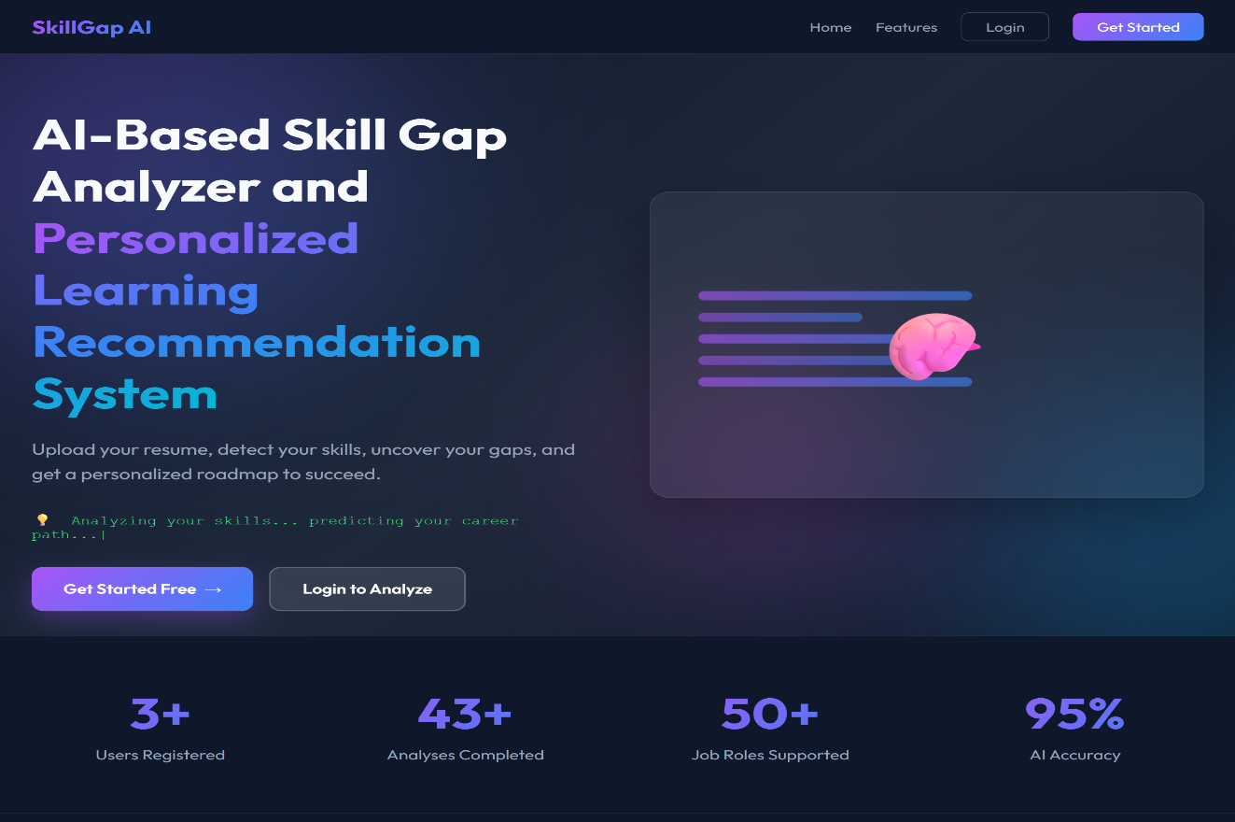

Figure 6.1: Main landing page of the AI-Based Skill Gap Analyzer and Personalized Learning Recommendation system

This is the starting page for the AI-Based Skill Gap Analyzer and Personalized Learning Recommendation system. It serves as the main entry point where users may learn about the platform, begin registration, or sign in to evaluate resumes and get personal learning recommendations and skill gap insights.

Register page for Job Seeker
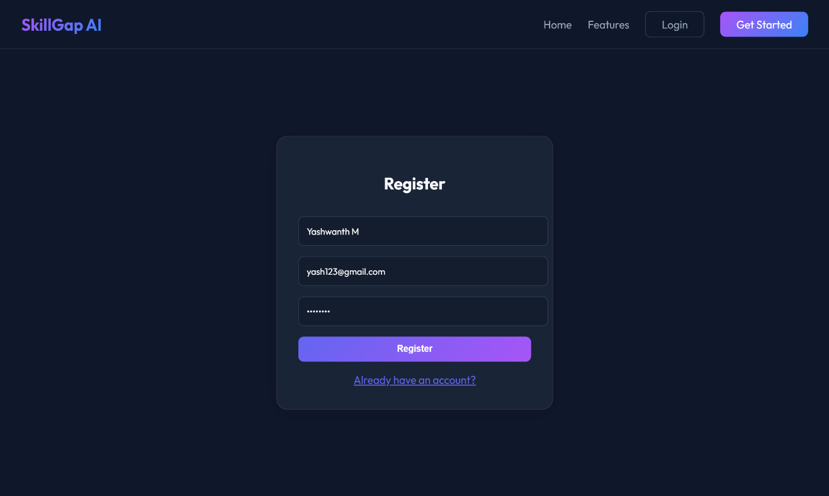

Figure 6.2: Register page for Job Seeker

This page is where users can sign up for the AI-Based Skill Gap Analyzer and Personalised Learning Recommendation system, new job seekers are able to open an account just by entering proper personal information. Registered users can then continue to sign in and utilize the features of the system.

Login page for Job Seeker
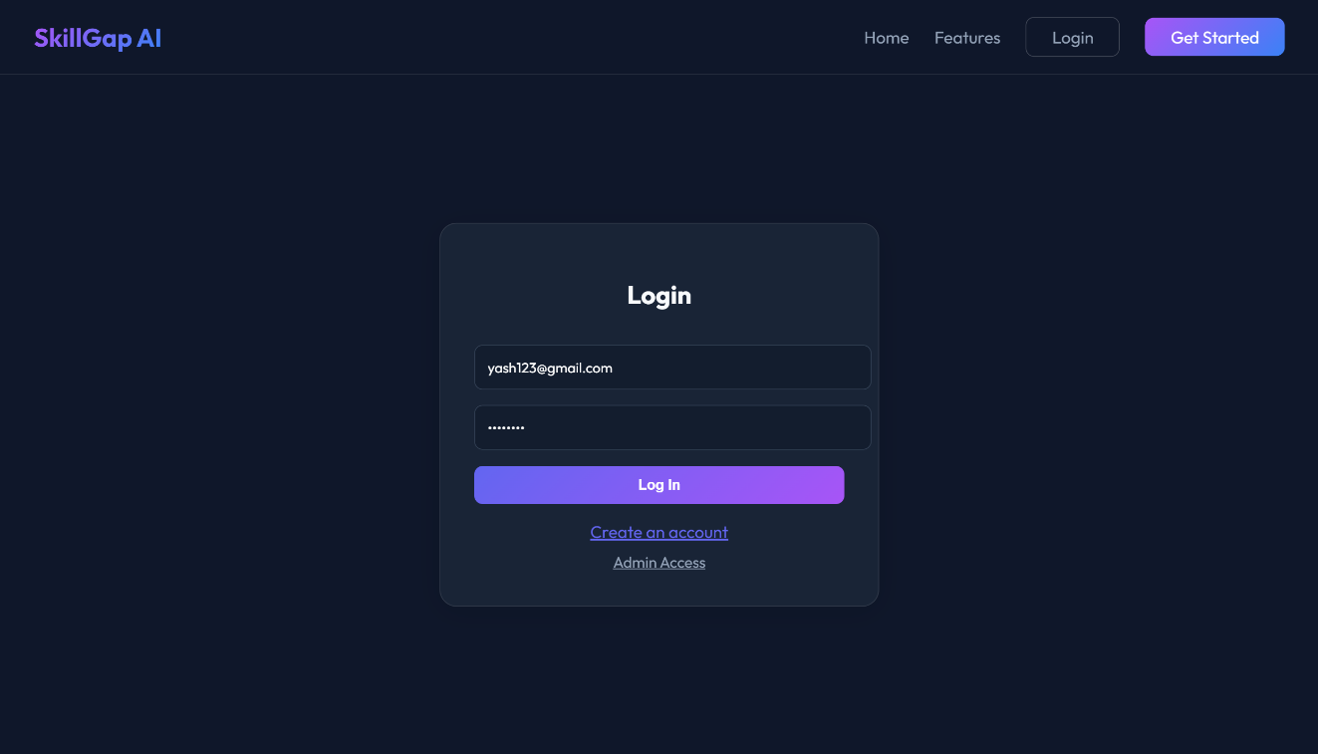

Figure 6.3 Login page for Job Seeker

The picture shows the login page of the AI-Based Skill Gap Analyzer and Personalized Learning Recommendation System. On this page, the users that already registered have the option of logging in their accounts just by putting in their email and password. The person whose sign in is successful will be taken to their customized home page automatically.

Home page
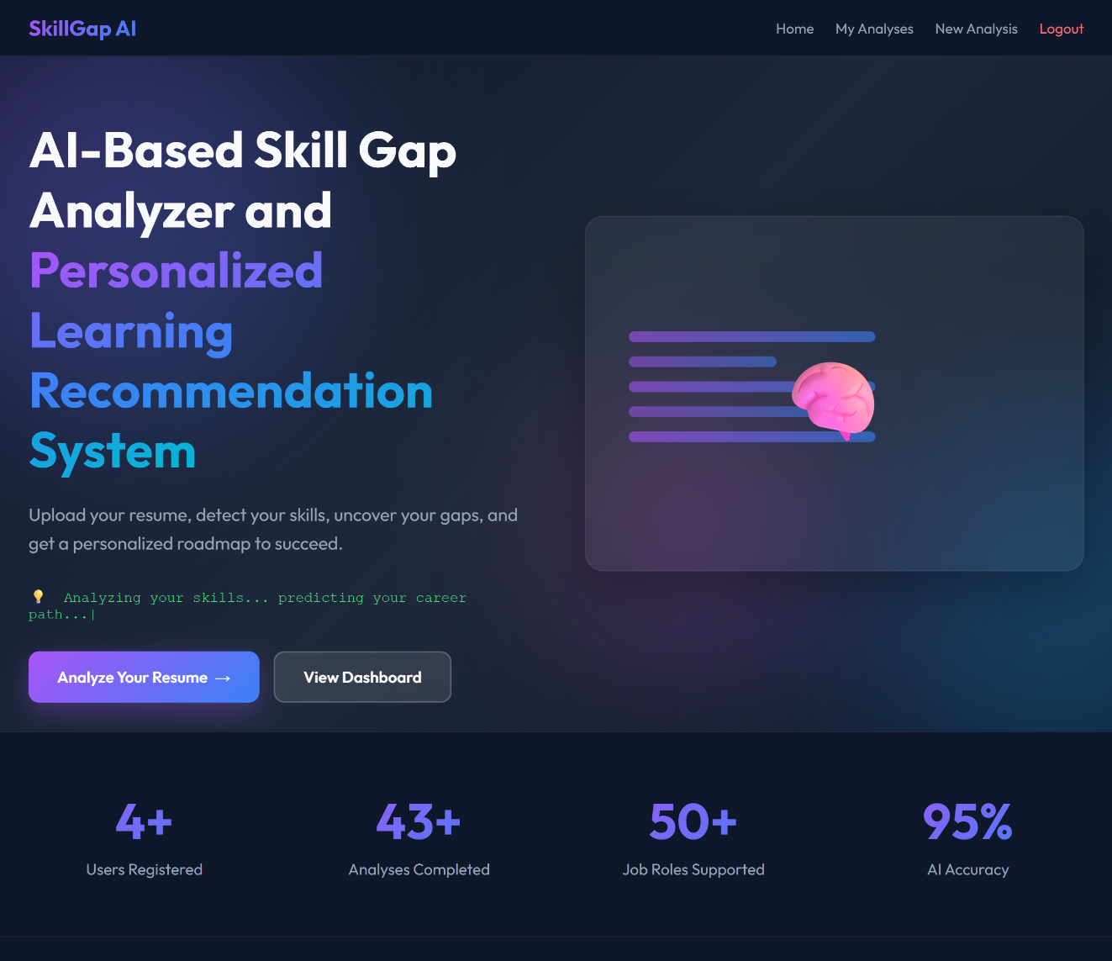

Figure 6.4 Home page for Job Seeker

In this image, we see the home page of system once the user is logged in. Users are able to start resume analysis, access their dashboard, and get insights into the system's performance in analyzing skills, spotting gaps, and offering tailored training and job recommendations through this page.

New Skill Analysis Page
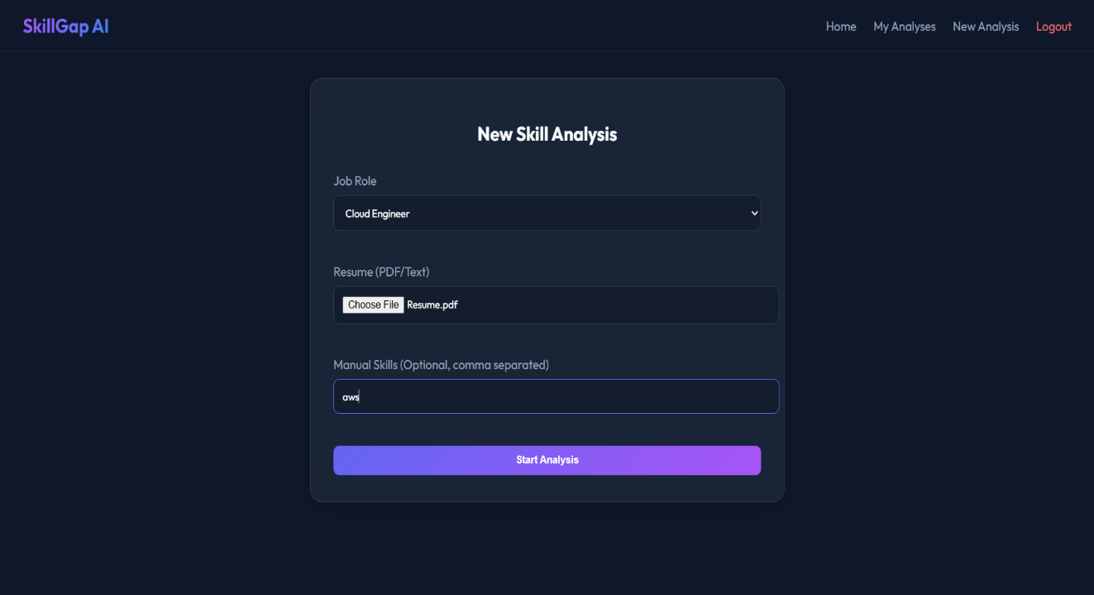

Figure 6.5 New Skill Analysis Page for Job Seeker

Through this page, the user gets the opportunity to begin a new skill analysis by choosing the target job role, uploading their resume, and optionally specifying other skills. The submission of information followed by the click of Start Analysis commences the AI-powered comparison of skills with the selected role.

Analysis Result page
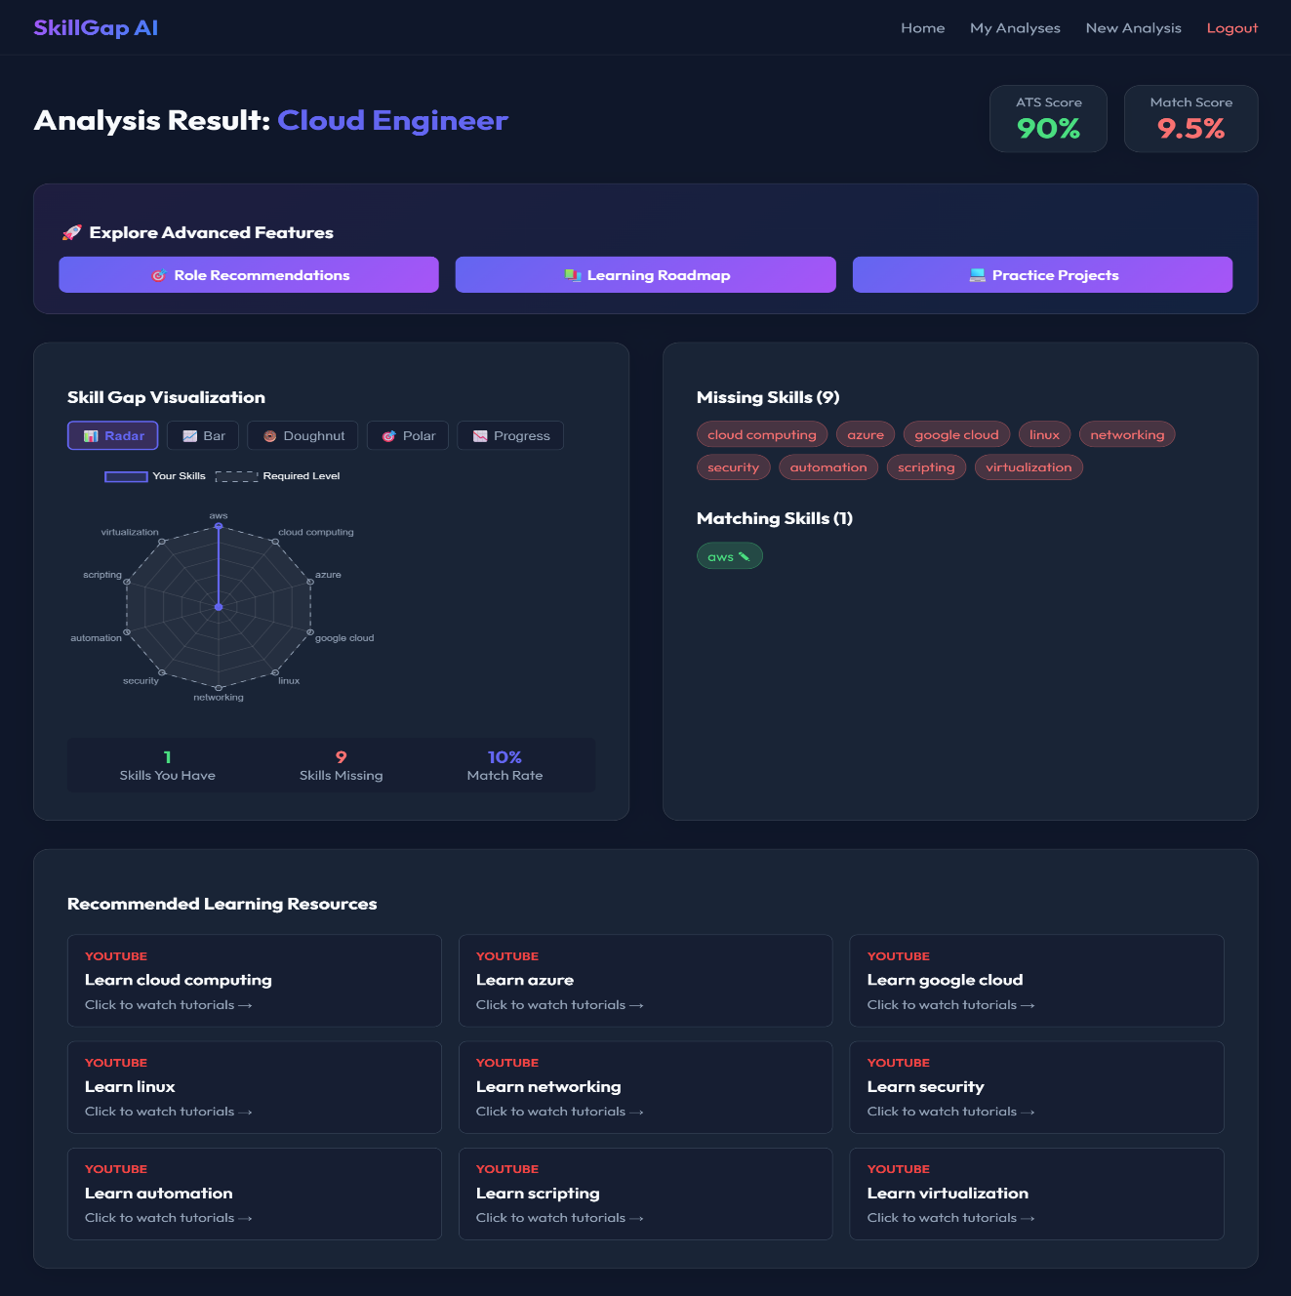

Figure 6.6 Analysis Dashboard for Job Seeker

The output from the AI-Based Skill Gap Analyzer and Personalized Learning Recommendation System is illustrated in the form of user dashboard for Cloud Engineer role. It displays the ATS score and match percentage of the user, makes the skill gaps clear with charts, and marks the skills that are both matching and missing. Besides, the page offers tailoring learning materials, suggesting roles, and practice projects that will assist the user in being skill match and career ready.

Recommended Job Roles Page
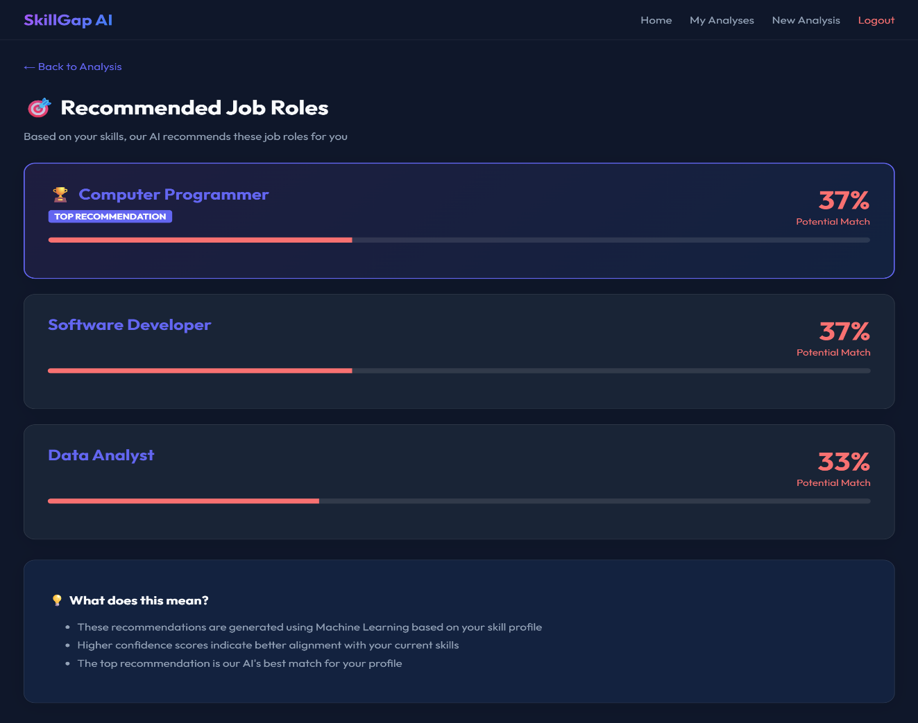

Figure 6.7 Analysis Dashboard for Job Seeker

The system suggests job roles on this screen according to the analyzed skills of the user. The user’s current skills are aligned with that role, and the potential match percentage is shown for each role. The top recommendation emphasizes the most appropriate career option, thereby aiding users in a clear understanding of their best job opportunities and also their areas for improvement.

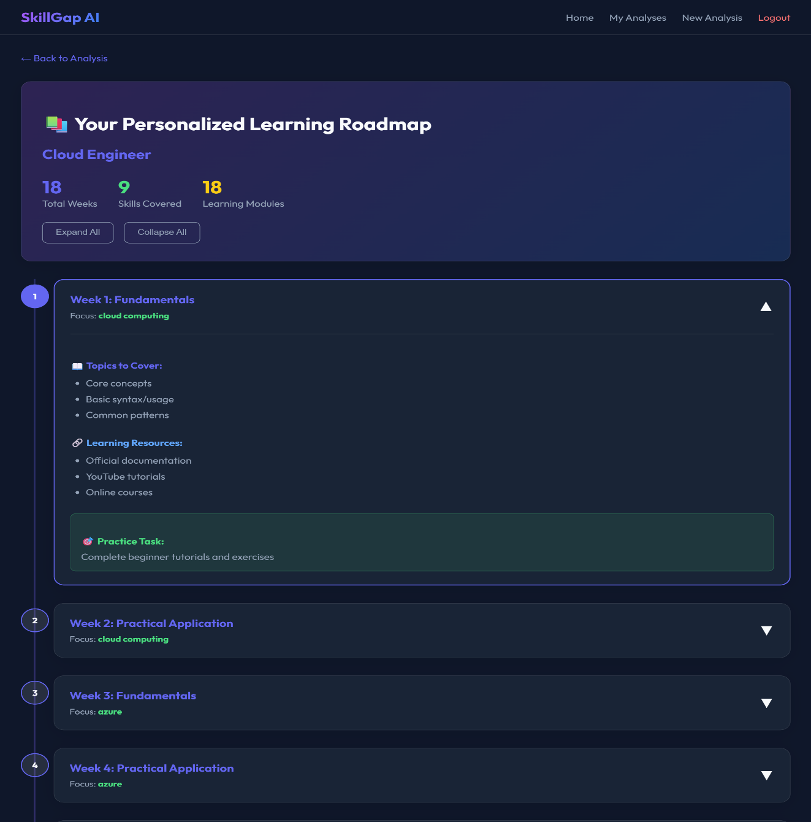
Personalized Learning Roadmap Page

Figure 6.8 Personalized Learning Roadmap for Job Seeker

The system has created a personalized, week-by-week learning roadmap on this page according to the chosen job position (Cloud Engineer). It specifies the total time, the skills that are included, and the modules of learning, as well as the elaborate weekly plans that contain the subjects, suggested resources, and practice tasks. The roadmap is a tool for the users to develop their lacking skills in a systematic way and to monitor their learning progress in a structured way.

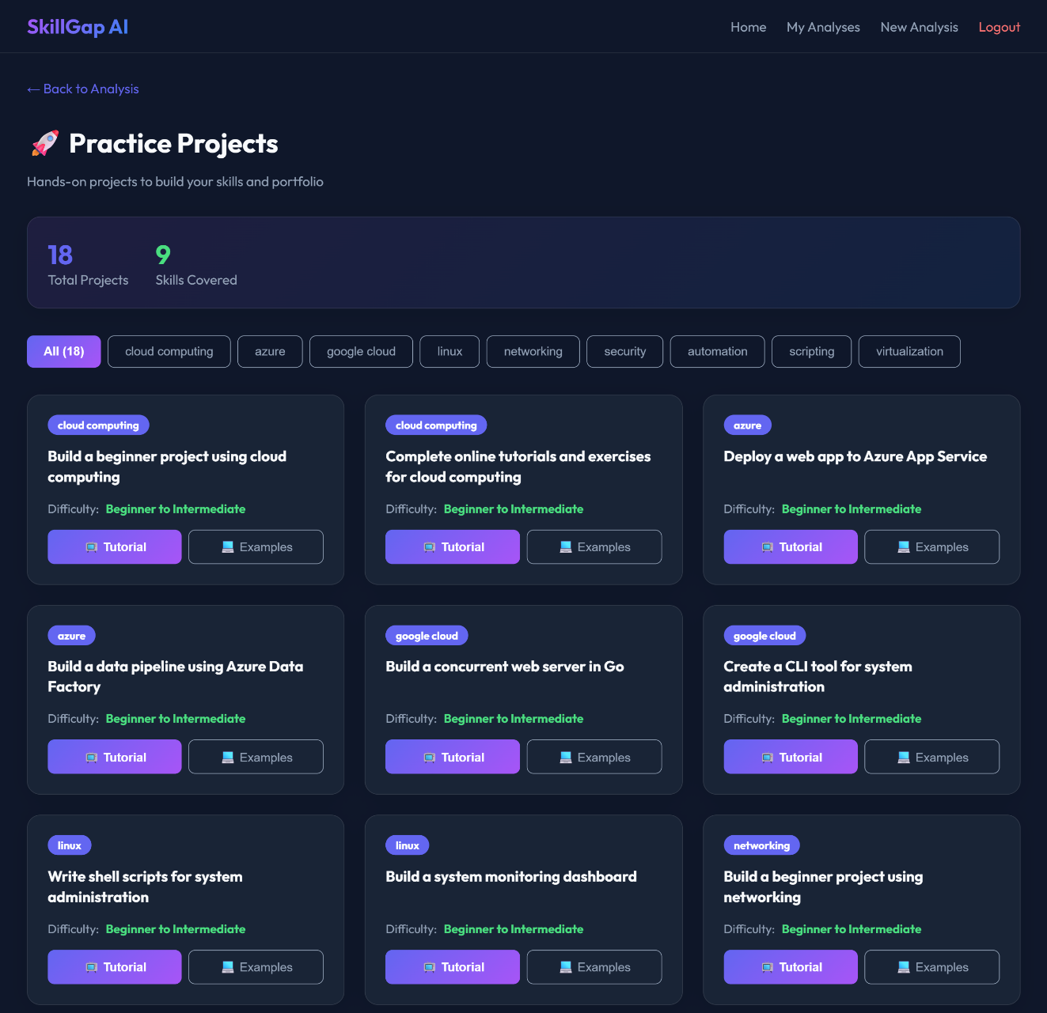
Practice Projects Page

Figure 6.9 Practice Projects for Job Seeker

This page presents a collection of actual projects created to let Job Seekers improve their skills and create a professional portfolio. Every project has tutorials and sample materials to aid learning together with its degree of difficulty. The website promotes hands-on practice in general to raise actual technical ability.

Skill Progress Monitoring Dashboard
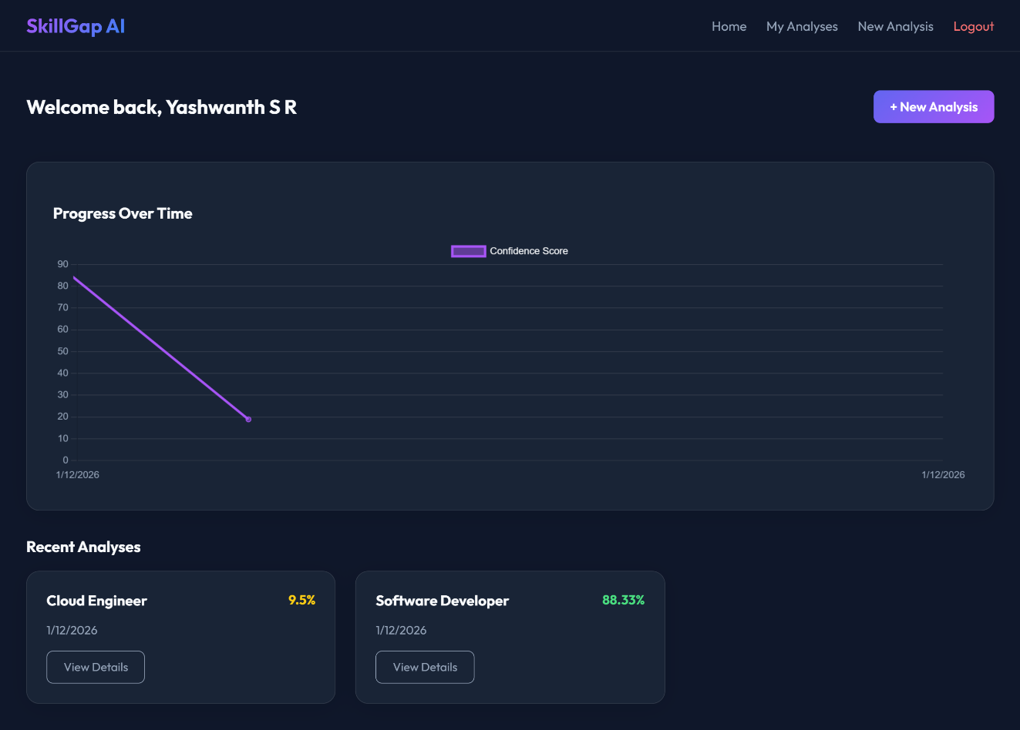

Figure 6.10 Job Seeker dashboard showing progress over time
A graph of the confidence score depicts the Job Seeker's progress over time in this dashboard. Additionally, it represents the latest skill assessments for various job positions with the corresponding percentages. The users have the option to initiate a new analysis or examine the detailed reports of earlier assessments.

Admin Login Page
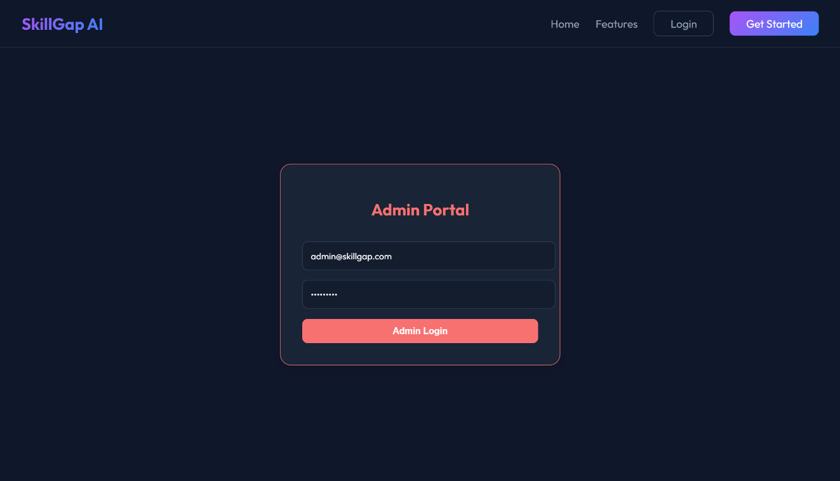

Figure 6.11 Admin Login Interface
The image shows the admin login page for the system. This page enables authorized administrators to log in securely by entering their registered e-mail ID and password.

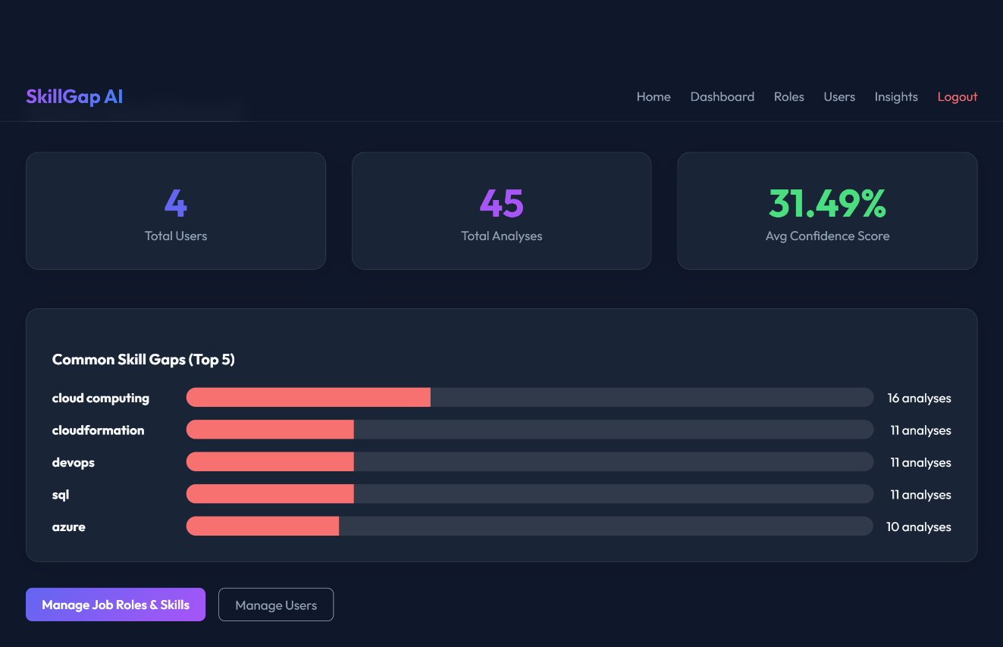
Admin Dashboard Page

Figure 6.12 Admin Dashboard Showing System Insights
The illustration presents the system's administrator control panel, which gives a picture of the total number of users, total analyses done and the mean confidence score. With that, the figure shows the most frequently detected skill gaps among users, which makes it possible to the admin to control job functions, skills and users while keeping an eye on the entire system's performance.

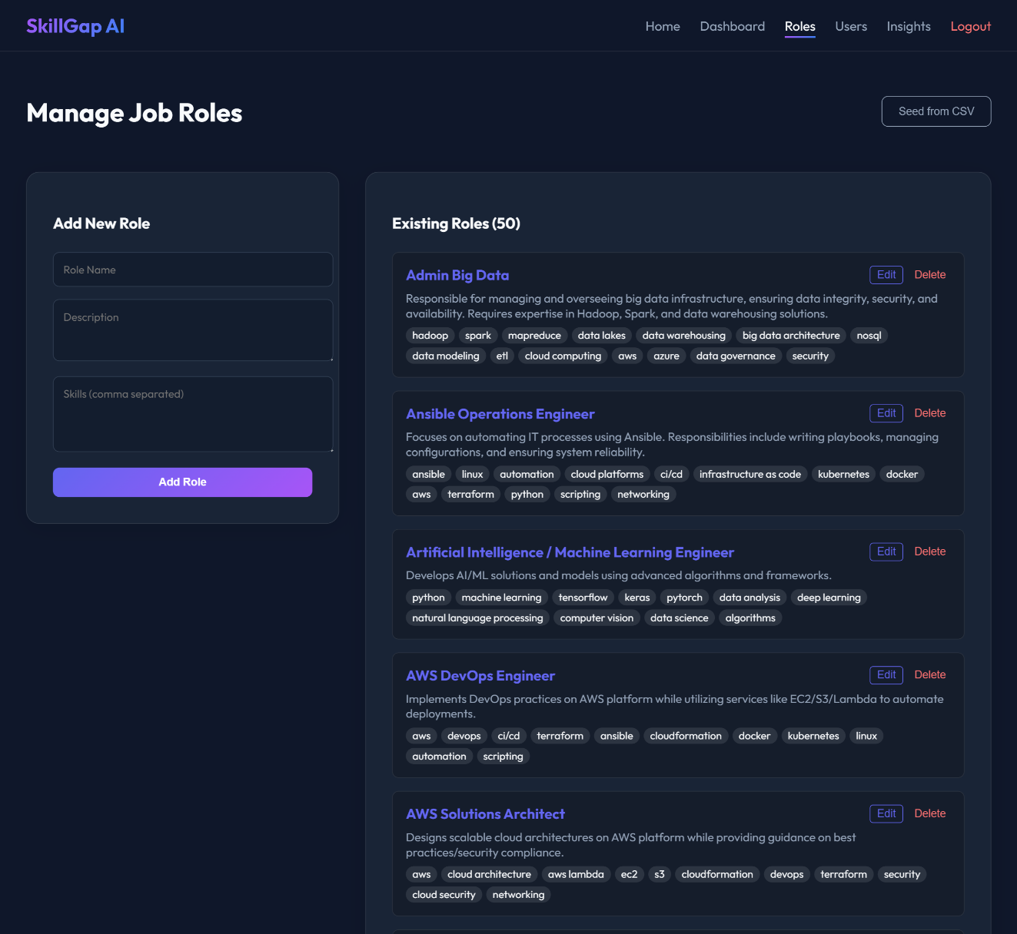
Managing Job Roles Page
Figure 6.13 Admin Interface for Managing Job Roles
The illustrated diagram depicts the administrator console that is responsible for handling the job roles that exist in the system. The roles of the system administrators include adding new job roles, specifying the needed skills, and they also have the right to see, modify, or remove the current roles that are existing, thus keeping the job-role database current for proper skill gap analysis and advice.

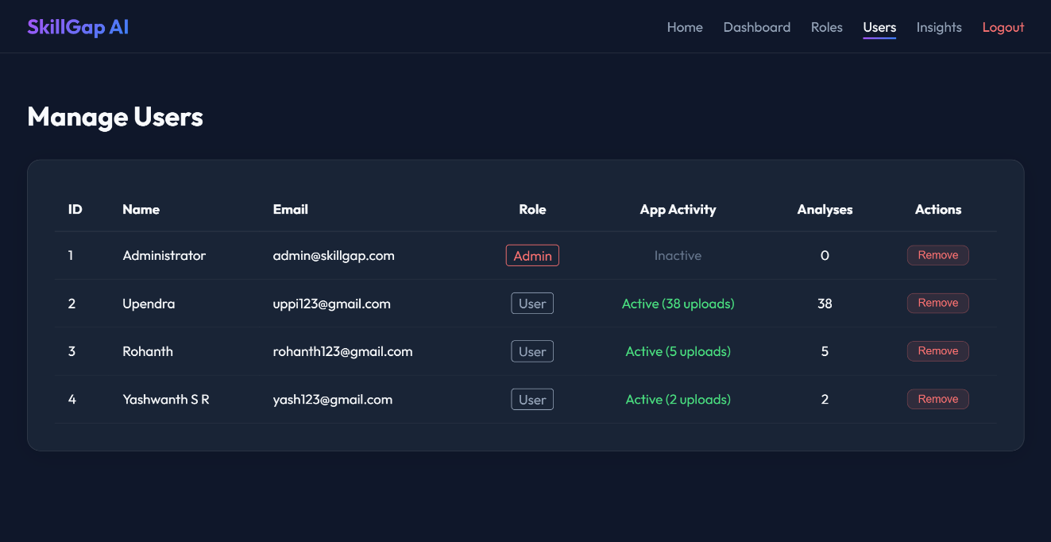
User Management Page
Figure 6.14 Admin User Management Dashboard
This picture displays the admin user management interface, which allows the administrators to view all individuals that are registered and to find out roles of them, if they are active or not, how many analyses they have performed, and perform actions like removing users in order to keep the system under control and secure.

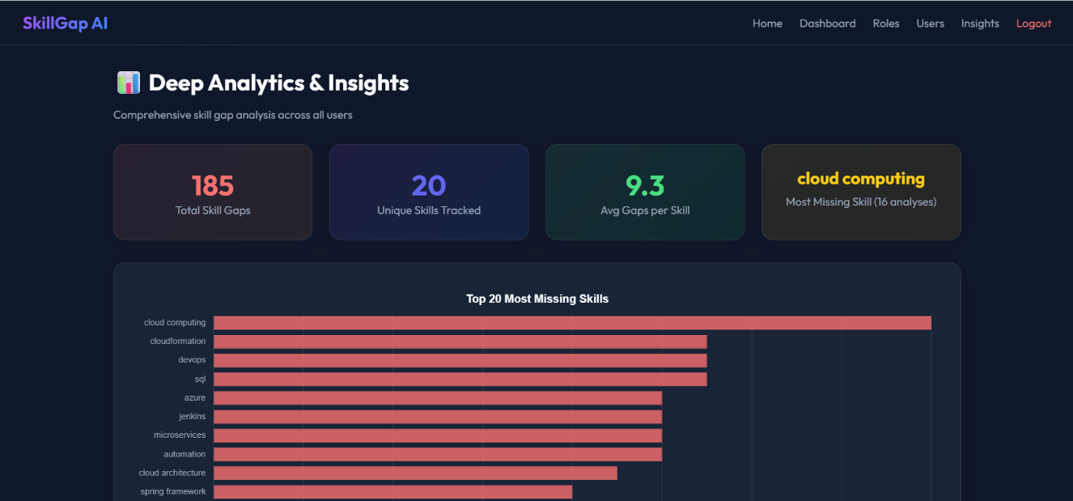
Deep Analytics and Insights Page

Figure 6.15 Skill Gap Analytics and Insights for Administrators
The deep analytics and insights dashboard for administrators is shown in this figure, which emphasizes the overall skill gap statistics, the most lacking skills, the average gaps per skill, and a visual distribution of the top missing skills among all users to facilitate the making of decisions based on data.

7. SOFTWARE TESTING

A step begins by spotting mistakes, then removes them from the work. Checking if things run as intended matters when confirming approval. Whether goals are met shows up clearly through this method.
Unit Testing
A single piece of code gets checked here, just one part at a time. Not everything together - each chunk stands alone during checks. The login process went under scrutiny first. Then came the file upload for resumes, examined step by step. Parsing skills from text followed next in line. Choosing job roles also faced close inspection. Bugs showed up sometimes - that was expected. Finding them early made fixing easier. Every test targeted only what it needed to. Nothing more slipped through unnoticed.
Functional Testing
Testing checked if core features matched what they were supposed to do. The process looked at how well the system analyzed resumes using AI, spotted missing skills, suggested suitable jobs, built personalized learning plans, then recommended hands-on projects. Every feature faced valid inputs alongside invalid ones. Behavior under these conditions showed whether responses made sense. Results came from mixing real-world cases with edge scenarios.
Integration Testing
When various parts in the system connect, their teamwork needs checking. In this case, making sure data moved smoothly from resume upload through AI parsing, then into skill gap review, followed by course suggestions, ending at dashboard changes. Each step passed details correctly to the next. Modules linked together performed without hiccups. Smooth handoffs meant no breakdowns in flow.
System Testing
System testing looked at the entire AI Skill Gap Analyzer as one unit. All the modules were brought together and put to test in a controlled setting to make absolutely certain the system agrees with both operational and quality-related specifications. This testing played a role in uncovering problems that were caused by the different subsystems communicating with each other.
Test Data
Test data was created in alignment with the Software Requirement Specification (SRS). The platform was put to test with sample resumes in PDF formats, different job roles, skill keywords, and various user credentials for both job seekers and administrators. This way testing scenarios that were realistic and reliable were ensured.
Test Report
It’s a document which contains all the results of the validation cases in the testing phase. It verifies whether if each module works how it should and concurrently it confirms successful log in of the user, correct AI-based analysis, right data storage, and proper retrieval of recommendations.
Test Cases
A test case is a description of a particular input, the conditions of execution, and system response that is expected to verify operation of the platform. Validation cases categorized to two, i.e. positive and negative test cases.
Positive Test Case: Valid input produces the expected result, such as a registered user successfully logging in.
Negative Test Case: Invalid input produces an error or denial of access, such as entering inaccurate login credentials.

Test Cases of AI-Based Skill Gap Analyzer and Personalized Learning Recommendation System

Test Case ID | Test Case Name | Test Description | Test Input | Expected Result | Actual Output | Status
TC01 | Admin Login | Validates admin login | Valid admin credentials | Redirect to admin dashboard | Login successful | Pass
TC02 | Job Seeker Login | Verifies job seeker authentication | Valid username and password | Redirect to user dashboard | Login successful | Pass
TC03 | Job Seeker Registration | Registers a new job seeker | Valid user details | Account created successfully | Account created | Pass
TC04 | Invalid Login | Prevents access for invalid credentials | Invalid username/password | Error message displayed | Access denied | Pass
TC05 | Resume Upload | Uploads resume file | PDF file | Resume uploaded | Upload successful | Pass
TC06 | Resume Parsing | Extracts skills from resume | Resume file | Skills extracted and stored | Skills extracted | Pass
TC07 | Skill Gap Analysis | Identifies missing skills | Resume + job role | Skill gaps displayed | Gaps identified | Pass
TC08 | Job Role Recommendation | Suggests suitable job roles | User skill profile | Recommended roles shown | Roles displayed | Pass
TC09 | Learning Roadmap | Generates learning plan | Selected job role | Roadmap generated | Roadmap displayed | Pass
TC10 | Practice Project Recommendation | Suggests practice projects | Skill gaps | Project list displayed | Projects shown | Pass
TC11 | Dashboard View | Displays user progress | Logged-in user | Dashboard loaded | Dashboard displayed | Pass
TC12 | Admin Manage Users | Displays user list | Admin access | User details shown | Users listed | Pass
TC13 | Admin Manage Job Roles | Adds new job role | Role details | Role added successfully | Role added | Pass
TC14 | Logout | Terminates user session | Logout action | Redirect to login page | Logged out | Pass

Figure 7.1: Table of test cases

- CONCLUSION

The AI-Based Skill Gap Analyzer and Personalized Learning Recommendation System have effectively managed to eliminate the difficulties that job seekers confront when trying to discover and rectify the missing skills that connect them to the industry. The combination of superior Artificial Intelligence and NLP has guide to an accurate resume analysis, skill gap detection, the recommendation of job roles, and a personalized learning roadmap. The deployment of spaCy, SBERT, and diverse AI assures deep semantic understanding instead of mere keyword matching.
Besides that, the system presents a very intuitive interface for job seekers, a comprehensive dashboard for administrators, and various other features for enhanced efficient management and analysis of the users’ data. Results of testing and validation indicate the platform is a reliable, secure, and fast yet accurate source of recommendations. To sum up, this project is an effective career guidance tool that not just increases employability but also supports informed career decisions and sets a strong future for AI-led recruitment and learning systems advancements.

- FUTURE ENHANCEMENT
The AI-Based Skill Gap Analyzer and Personalized Learning Recommendation System has a modular, flexible, and scalable architecture, which is suitable for future upgrades and feature expansion. One thing clear is better tools already there can do more. What comes next might surprise - new pieces added on could lift how much gets done. Changes ahead aim at shifting how it all works
Advanced AI Analytics: Picture this - the admin panel gets smarter. By adding deeper analysis tools, it spots hidden trends in skills. Not just what people know, but where they’re headed. Roles start making sense before they happen. Progress logs turn into clear signs of what training works. Clarity comes from how users actually move through material.
Mobile Application: When learning kicks off, alerts can pop up on phones. Notifications reach people right away, wherever they happen to be. Moving through the day, users still get suggestions without hassle. Separate apps work smoothly on both Android and iOS devices. Access stays simple, no matter the location.
Improved Skill Gap Analysis: Where gaps show up in someone's abilities, guidance could steer them into internships instead of just classes. One path forward includes recognizing what jobs require, then matching people with respected certifications. Goals matter here - personal ambitions shape which opportunities make sense.
User Feedback and Progress Tracking: Feedback from users lights up the path forward. As progress gets recorded in detail, it shapes how suggestions grow clearer over time. When steps are tracked closely, personal learning routes adjust naturally. Clear records mix with real reactions, making each next move feel more grounded.
The above advancements would support the platform of usability, precision and long time benefit to both the job seekers and system administrators.

APPENDIX A: BIBLIOGRAPHY

[1] Jurafsky, D., and Martin, J. H., Speech and Language Processing, Pearson Education, 2023.
[2] Reimers, N., and Gurevych, I., “Sentence-BERT: Sentence Embeddings using Siamese BERT-Networks,” Proceedings of EMNLP, 2019.
[3] Honnibal, M., Montani, I., Van Landeghem, S., and Boyd, A., “spaCy: Industrial-Strength Natural Language Processing in Python,” Zenodo, 2020.
[4] Géron, A., Hands-On Machine Learning with Scikit-Learn, Keras, and TensorFlow, O’Reilly Media, 2019.
[5] Pedregosa, F., et al., “Scikit-learn: Machine Learning in Python,” Journal of Machine Learning Research, vol. 12, pp. 2825–2830, 2011.
[6] Kuhn, P., and Skuterud, M., “Job Search Methods: Internet versus Traditional,” Monthly Labor Review, vol. 123, no. 10, pp. 3–11, 2000.
[7] Aparanji, P. P., and Tripathi, J. P., “Review of Job Portal in Recruitment Process Life Cycle,” Journal of Emerging Technologies and Innovative Research, vol. 5, no. 1, pp. 367–369, 2018.
[8] Brown, M., Impact of Artificial Intelligence on Job Matching Algorithms, Ph.D. Dissertation, University of California, Berkeley, 2021.
[9] Welsh, E. T., Wanberg, C. R., Brown, K. G., and Simmering, M. J., “E-learning: Emerging Uses and Future Directions,” International Journal of Training and Development, vol. 7, no. 4, pp. 245–258, 2003.
[10] Acharya, K., “AI-Based Skill Gap Analyzer and Learning Recommendation System,” SSRN Electronic Journal, 2024.

